DBMS PROJECT
ON
INVENTORY MANAGEMENT SYSTEM



Session 2025-26
Computer Science and Engineering (Core)

BY-
- Harshika Rai
- Nandini Gaur
- Keshav Bhola
- Keshav Khandelwal

TO- Sir Neeraj Pratap

INVENTORY MANAGEMENT SYSTEM

Introduction

An Inventory Management System (IMS) is a software application used to manage and track products, stock levels, orders, suppliers, and customers in a business. It helps organizations maintain accurate records of goods available in stock and ensures smooth business operations.

The system reduces manual work, minimizes errors, and improves efficiency by automating stock tracking, order processing, and reporting. It is widely used in retail stores, warehouses, supermarkets, and manufacturing companies.

System Modules

- Product Management – Add, update, delete product details
- Supplier Management – Maintain supplier records
- Customer Management – Store customer details
- Order Management – Record and process orders
- Inventory Tracking – Monitor stock levels

Advantages:
- Saves time and reduces paperwork
- Improves accuracy of stock records
- Prevents stock shortages
- Enhances business productivity
- Provides better decision-making reports

ER Diagram

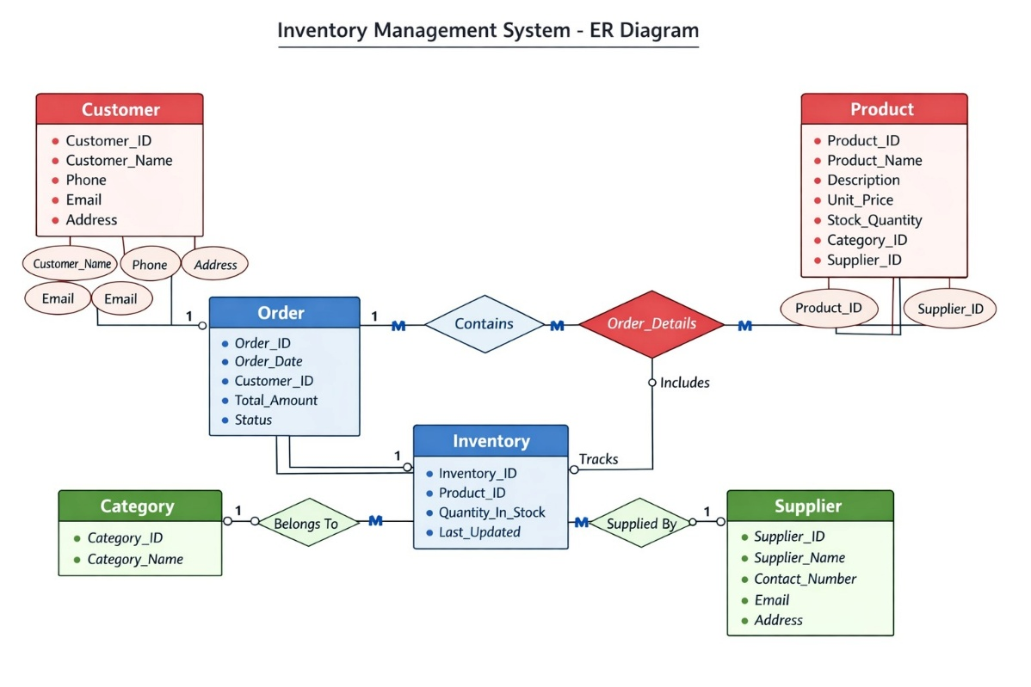
Queries-
1-Create database:
2-Create and insert data in table Product:
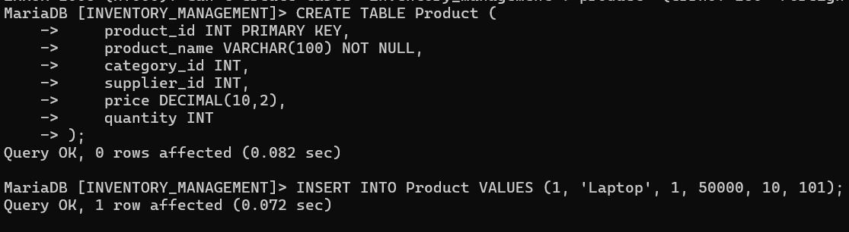
3-Create table category:
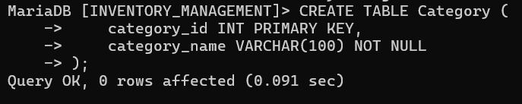
4- Create table Supplier:

5-Create table Customer:
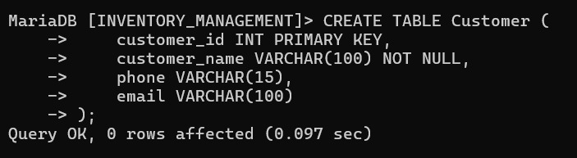
6- Create table orders:

7-Create Table order_details:
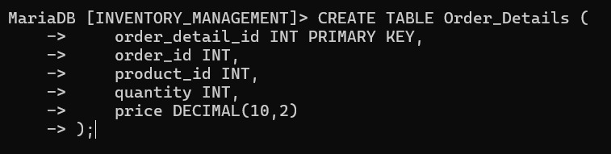
8-Insert into Customer:

9-Insert into Order and Order_details:
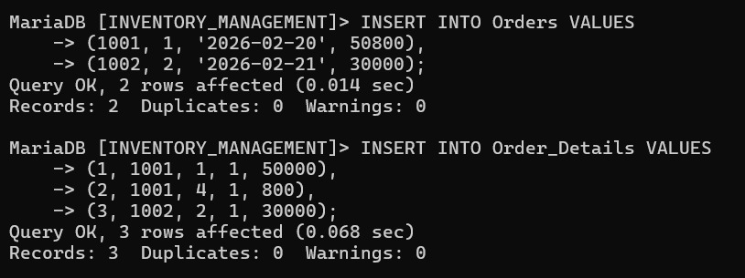
10- Display information in all tables:
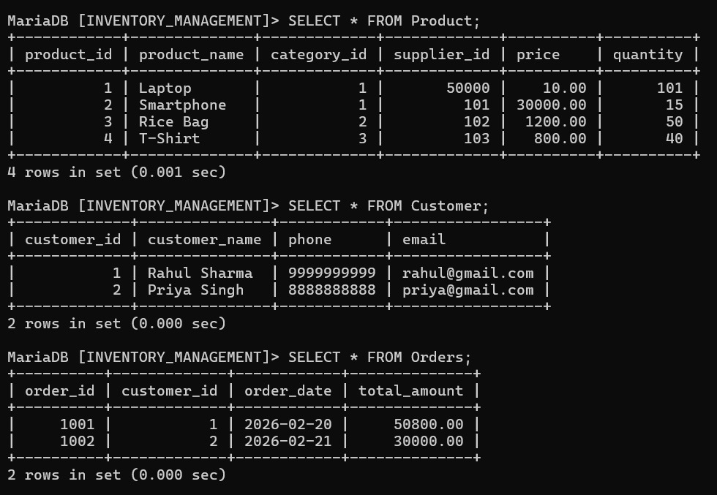
11- Find names and prices of products costing more than 500:
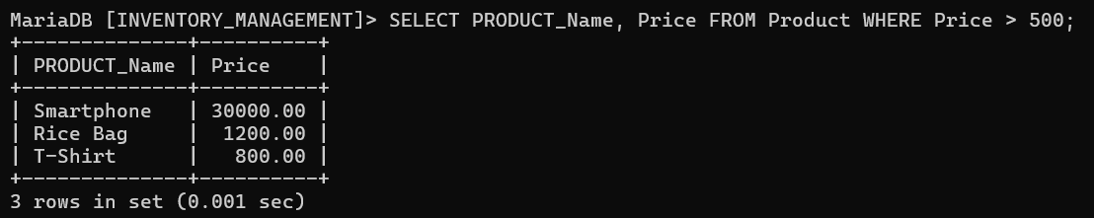
12- Find products whose stock is between 5 and 20.
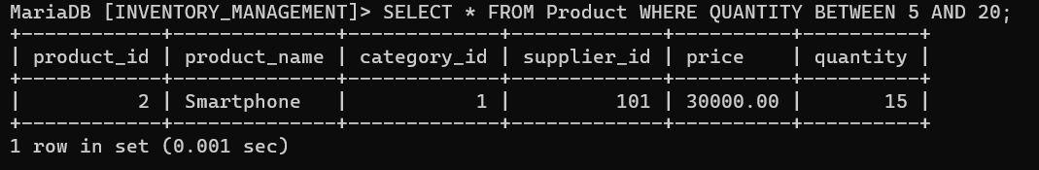
13- Find names of customers from Delhi.
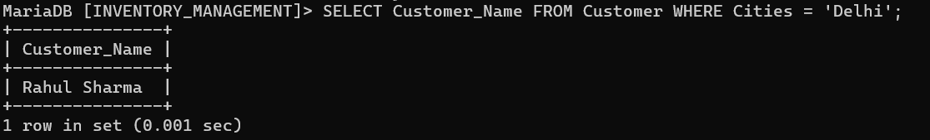
14- Find orders placed after 1 Jan 2025.
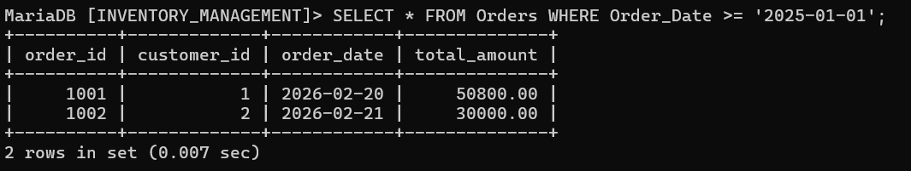
15- List product names in descending order of price.
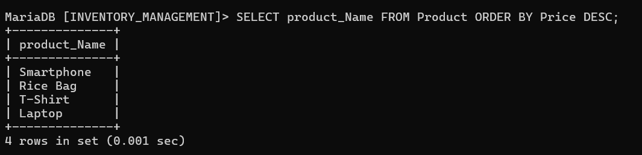
16- Find all unique cities of customers.
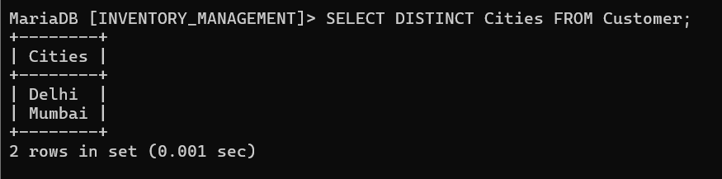
17- Find products whose name starts with ‘S’.
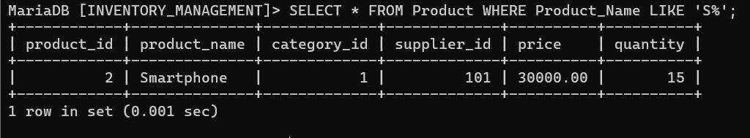
18- Find products that are out of stock.
19- Find customers whose names contain ‘a’.
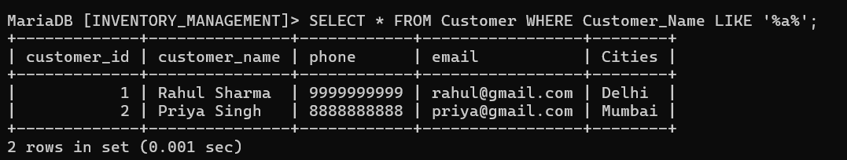
20- Display products sorted by stock in ascending order.
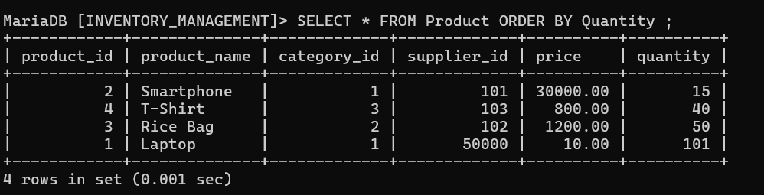
21- Find total number of products.
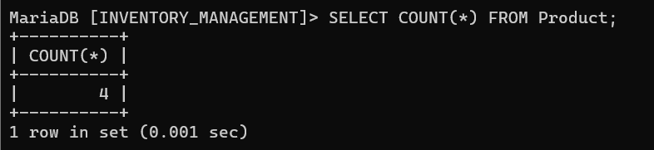
22- Find total stock available.
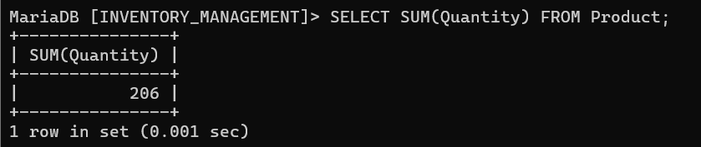
23- Find average price of products.
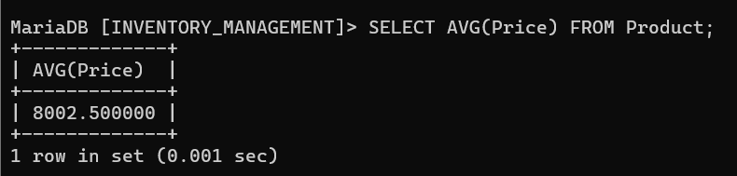
24- Find highest priced product.
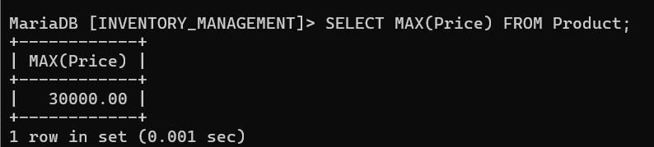
25- Find lowest priced product.
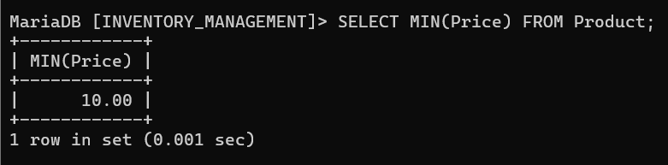26- Count number of products in each category.
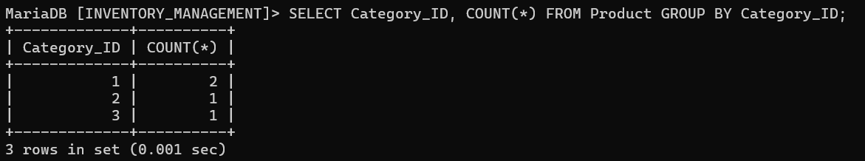
27- Find number of orders per customer.
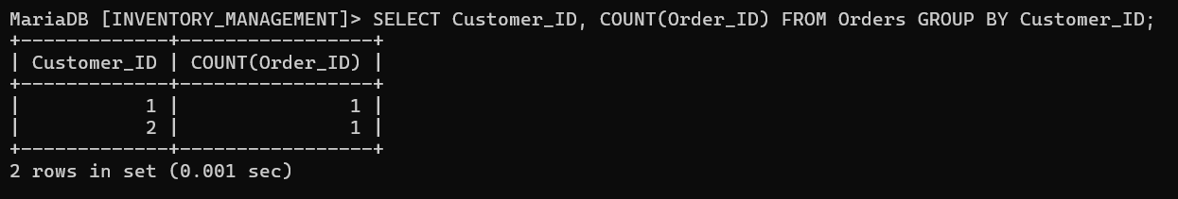
28- Find total quantity sold for each product.
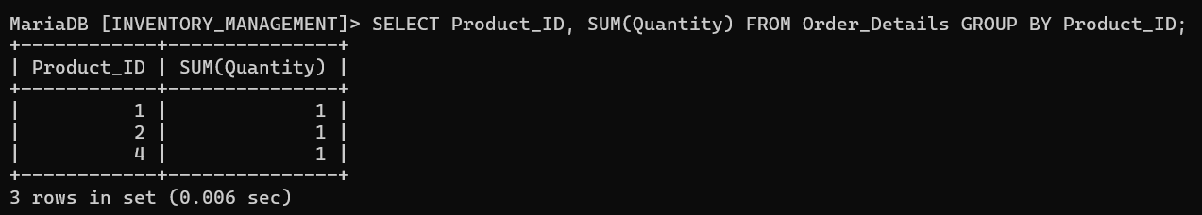
29- Find products with total sales quantity greater than 10.
30- Find average price of products in each category.
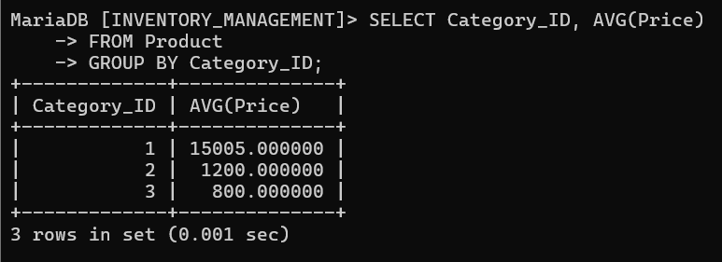
31- Display product name with its category name.
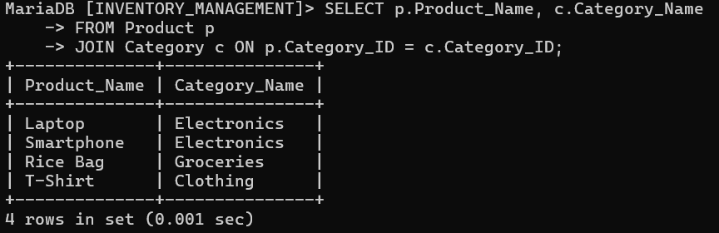
32- Display order ID with customer name.
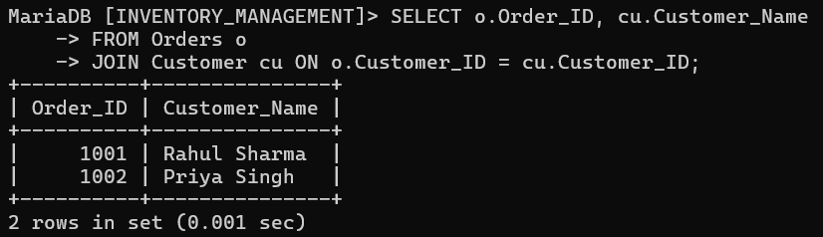
33- Display order details with product name and quantity.
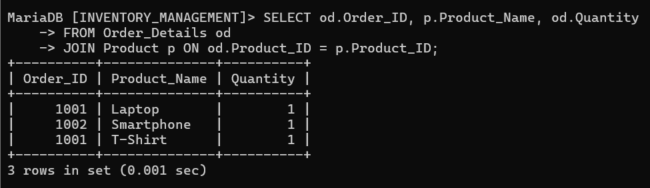
34- Display all customers and their orders (if any).
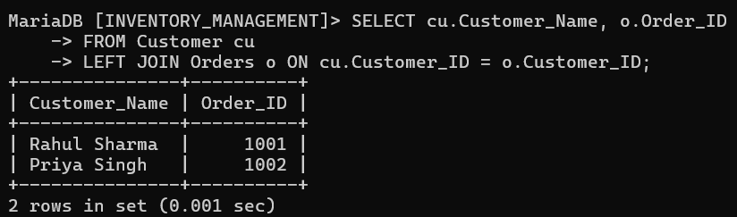
35- Display all products and their ordered quantities (if any).
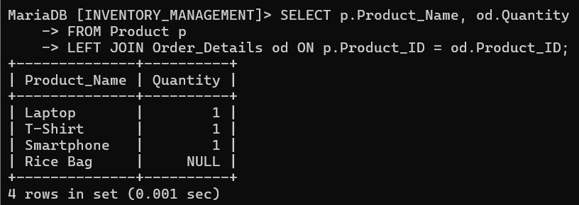
36- Display order ID, product name, and quantity.
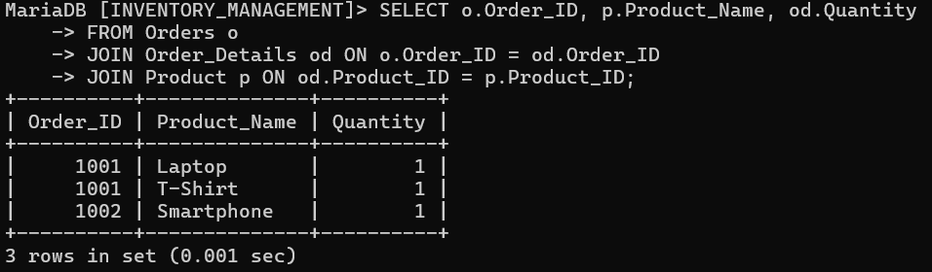
37- Display customer name and products purchased.
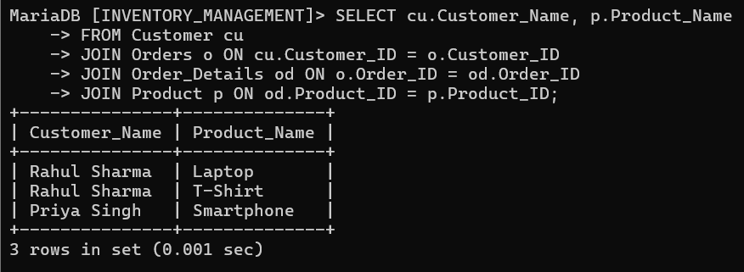
38- Display category name with number of products.
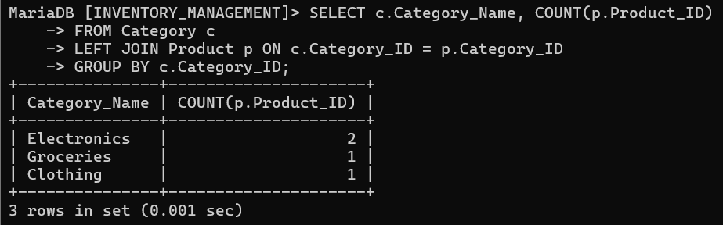
39- Display customers with number of orders.
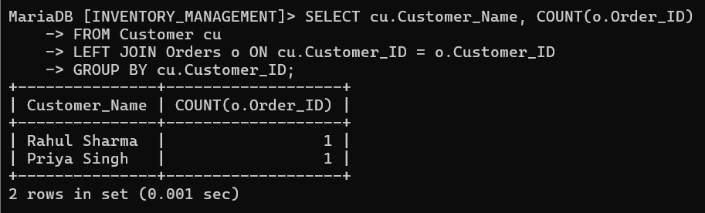
40- Display product name with total quantity sold.
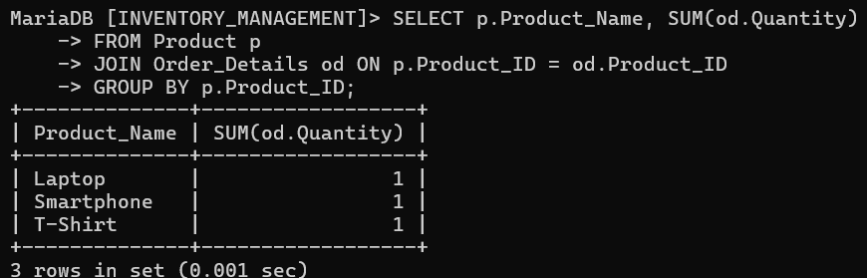
41- Find products priced above average price.
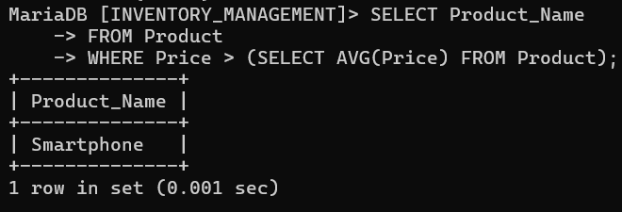
42- Find the most expensive product.
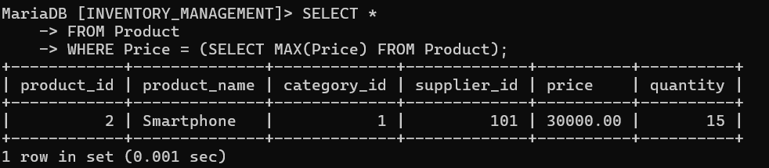
43- Find the cheapest product.
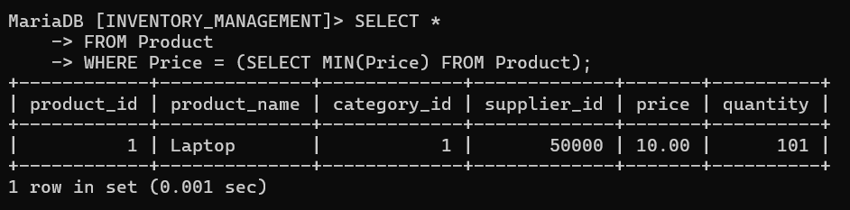
44- Find customers who have placed orders.
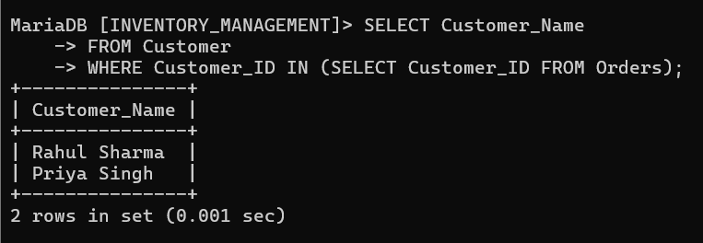
45- Find customers who have not placed any orders.
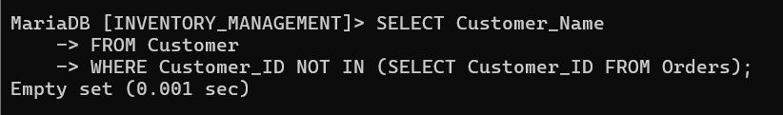
46- Find products ordered with quantity greater than 5.
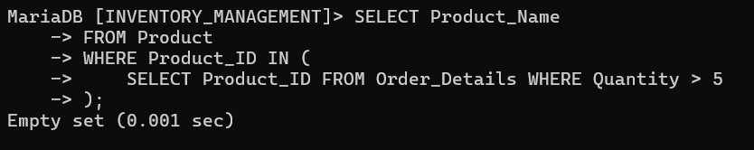
47- Find product with highest total sales quantity.
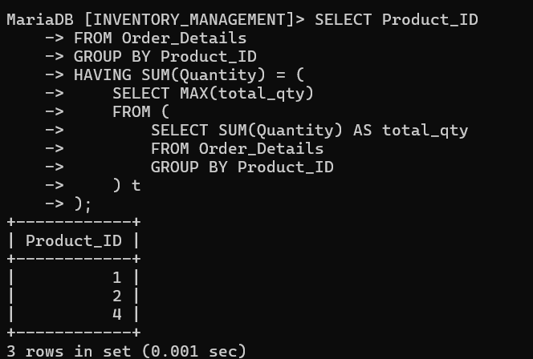
48- Find orders placed by customer ‘Rahul’.
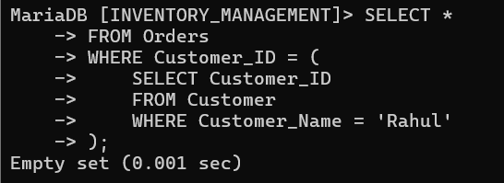
49- Find products in Electronics category.
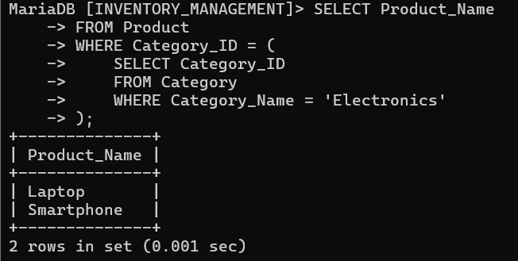
50- Find the latest customer who placed an order.
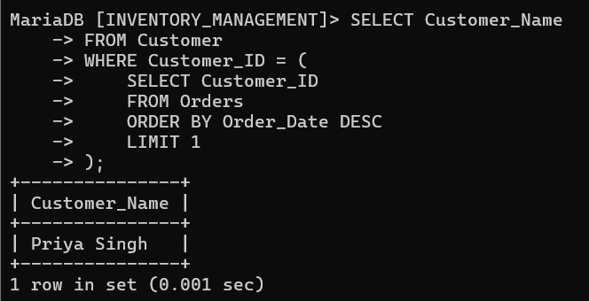

Conclusion :
The Inventory Management System plays a crucial role in modern business management. It helps in maintaining accurate stock records, managing suppliers and customers, and processing orders efficiently.
Overall, the system ensures smooth inventory control and improves overall organizational performance.

